# FinFamily 11 Development environment

## Java

Install Java 8 SDK

## Eclipse

Download and install latest Eclipse IDE for Java EE Developers

## Subclipse

Install Subclipse 1.8.x. You have to install this version older or newer doesn’t work.

Select “Help / Install new software”

<http://subclipse.tigris.org/update_1.8.x>

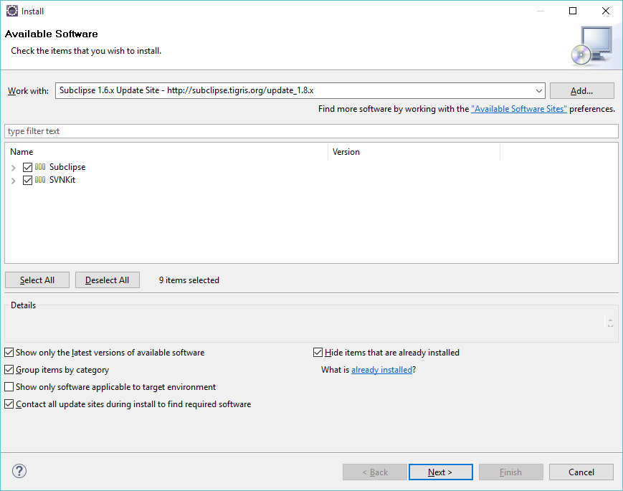

Click Next

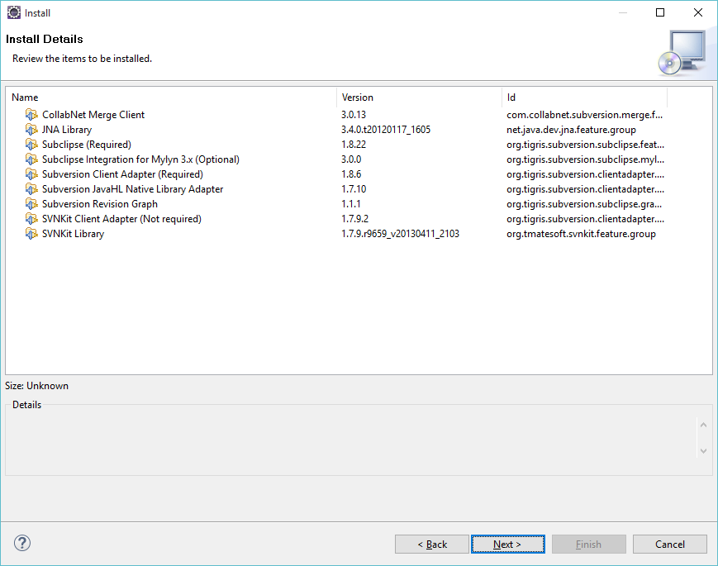

Click Next

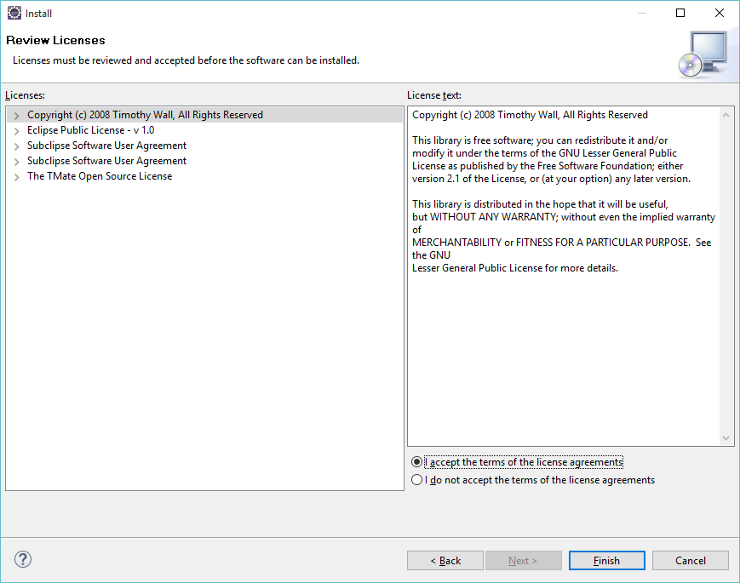

Click Finish

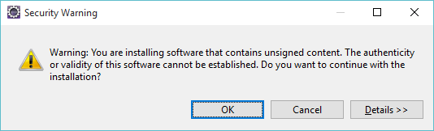

Click Ok

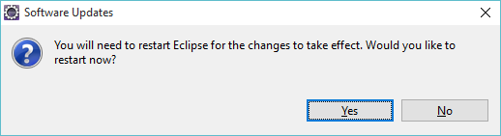

Click Yes

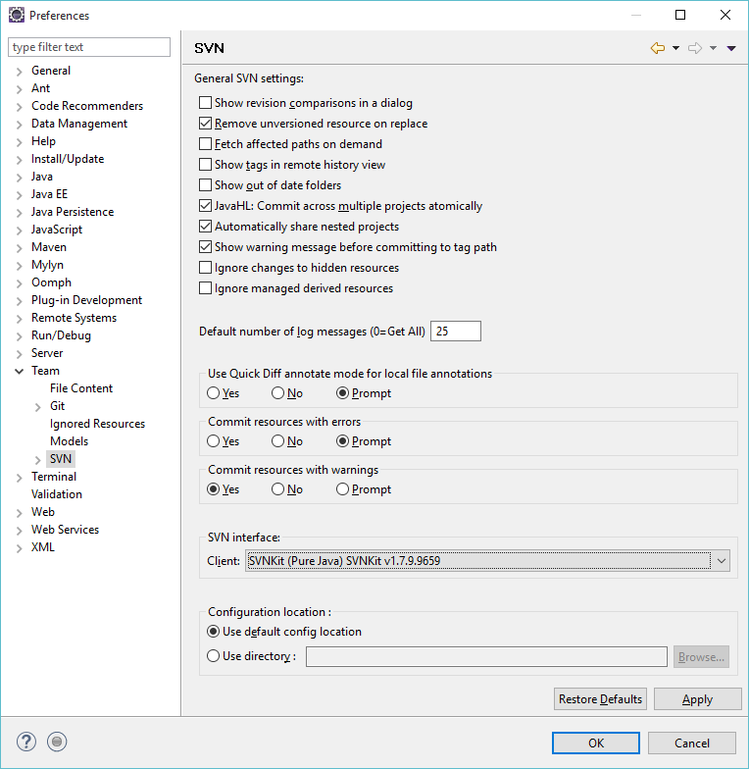

Change SVN interface in Window / Preferences

## Check out Codes from SVN

Select SVN Repository Exploring Perspective and Select New / Repository location

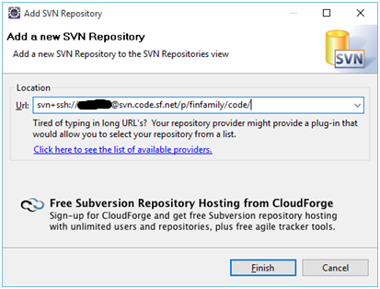

Write correct Url. Use your own SourgeForge username.

Click Finish.

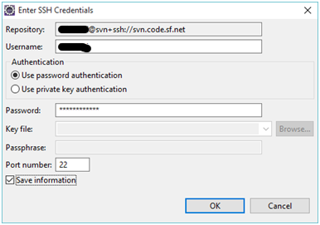

Click Ok.

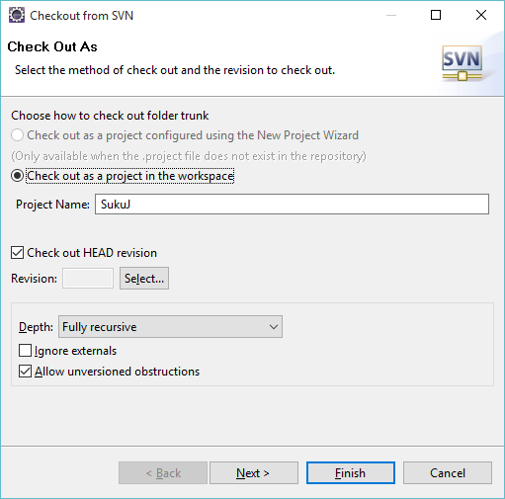

Checkout FinFamily codes from trunk.

Click Next.

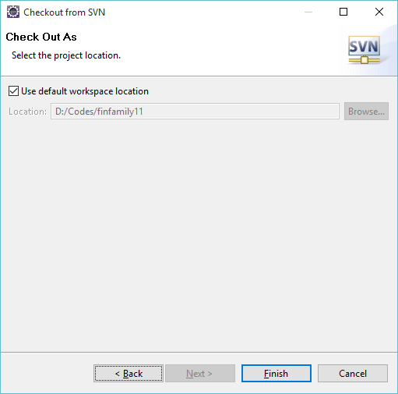

Click Finish. Wait until your codes are fetched from SVN.

## Change Java definitions

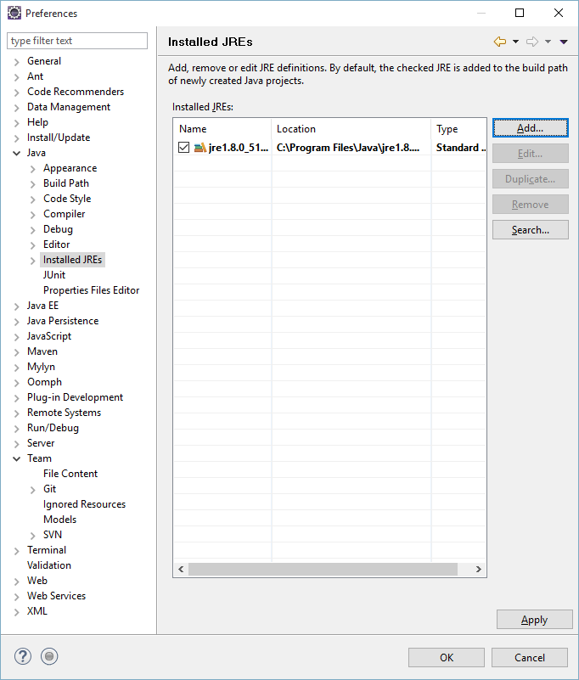

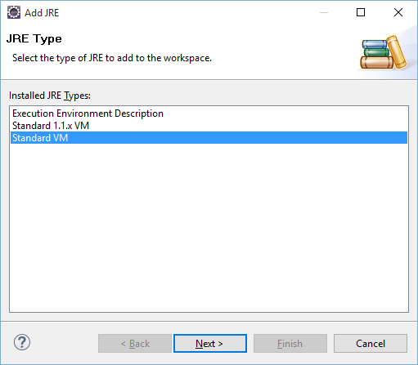

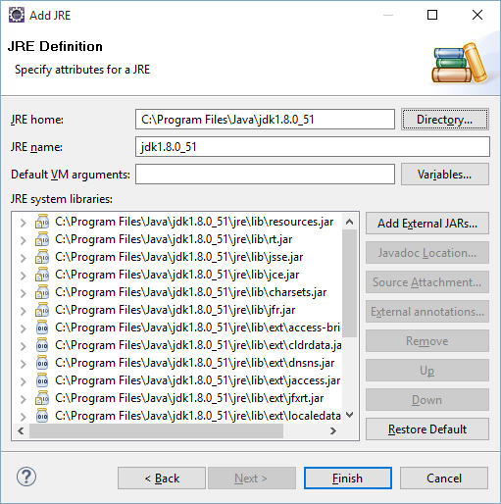

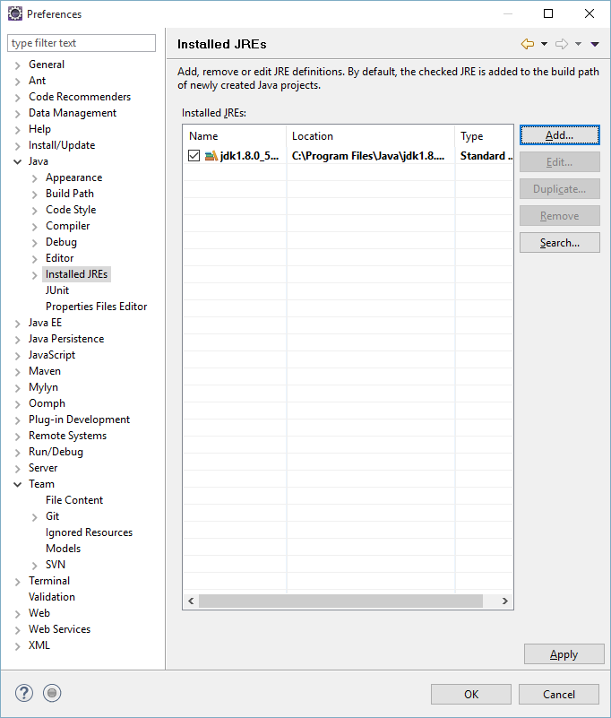

## Text file encoding

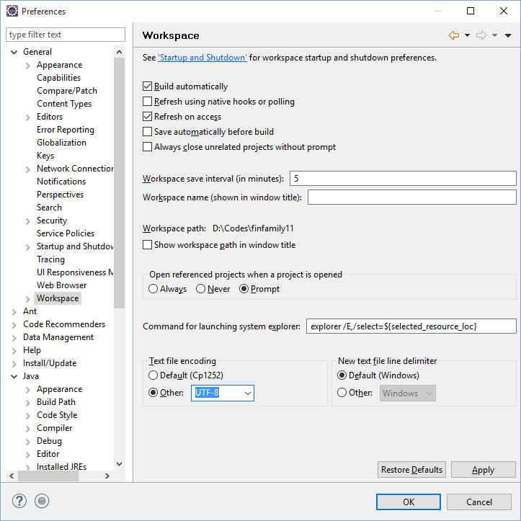

## Run configuration

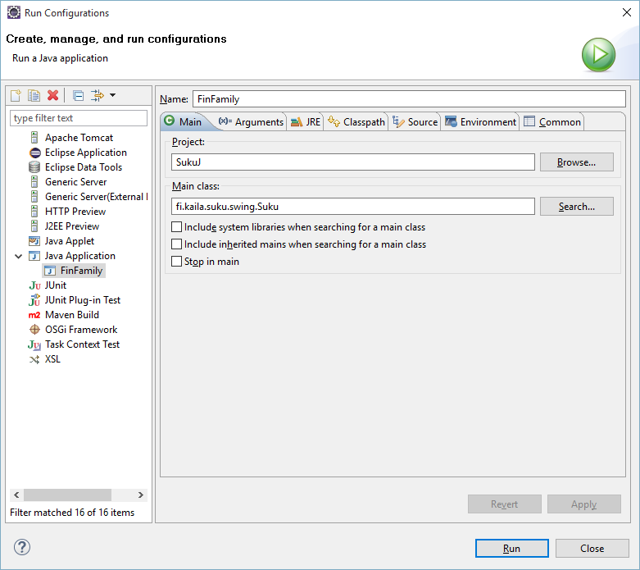

# Inno Setup

Install Inno Setup

<http://www.jrsoftware.org/isinfo.php>

# Launch4J

Install Launch4J

<http://launch4j.sourceforge.net/index.html>

# Ant

Install Ant

<http://ant.apache.org/>

# Build

buildit.bat